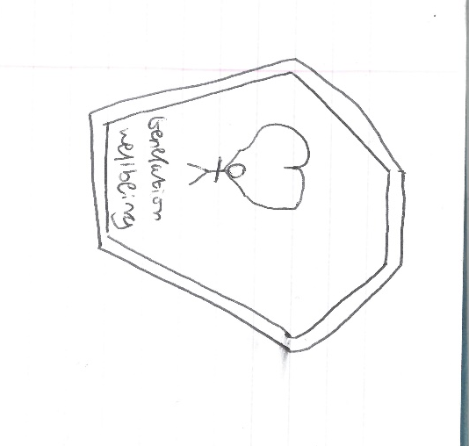
This is a very rough sketch of the idea I have for the logo (not a very good sketch).

It is very basic and should be no problem to create in Photoshop, it also relates to health and shows a heart in the background to try and promote the idea of being healthy.
It has the name of the website (generation wellbeing) on the logo so it fits onto the website if we decide to use it or someone else’s logo.
The logo itself is inside of a pentagon because it is easy to make and it can have a variety of colours that relate to the website.
I was thinking the colours should be orange (my website colour) and maybe a green because this is the colour that people typically associate with being healthy.

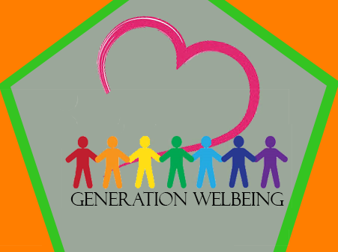
This is the logo I later created in Photoshop.
This logo is very basic and was easy to make, it also effectively does its job of representing the website as it has the grand site name and it c community of people in the middle who are coming together to stay healthy.
The heart in the background also represents the idea of being healthy.
The pentagons I created help it to stand out and also the orange background matches the colour of my website so it will fit the website better.
Finally the different coloured people signify the different colour themes we all was given to our respective area about health in young adults.
Overall the finished logo is based off the original although it has been better developed and given improvements to better relate and signify the idea generation wellbeing website.

